Inventory Manager Group Project

# Purpose, Scope and Vision

The purpose of this project was to create an inventory tracking application that could be used by a warehouse organization. This application will be secure (requiring user authentication) and will manage creating categories of inventory, adding products to categories, ordering inventory and completing orders for clients removing items from inventory. This will ensure the entire cycle is logged within the system.

There are two types of users: Administrators and Basic users. Basic users can log into the system, update their information (name, email and password), request items to purchase and fulfill an order. Administrative users can view, create and manage users, view, create and edit categories and products and all the functions of a basic user.

To create, edit or categories and products an administrator will need to navigate to the Inventory Manager menu. Within this module administrators can add and edit product categories and product names.

To request items from a supplier an user would need to navigate to Order Manager. Within this module users can view past orders, create and edit outstanding orders.

To fulfill a purchase request from a customer a user will navigate to the Store Manager module where orders are fulfilled.

# Backlog Burndown and Burn Up

## Sprint 1:

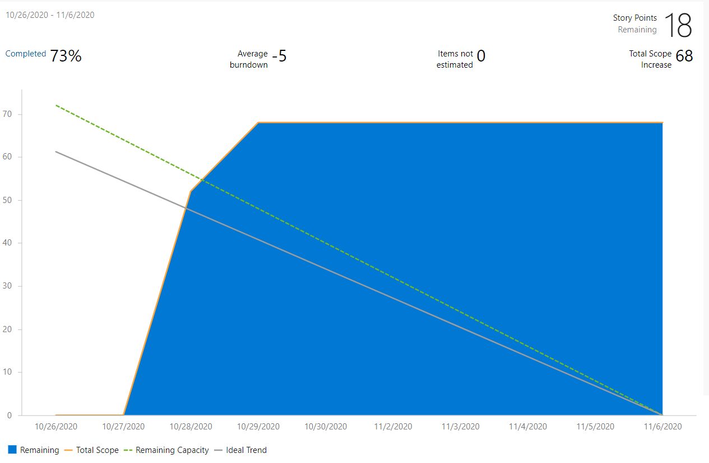

## Sprint 2:

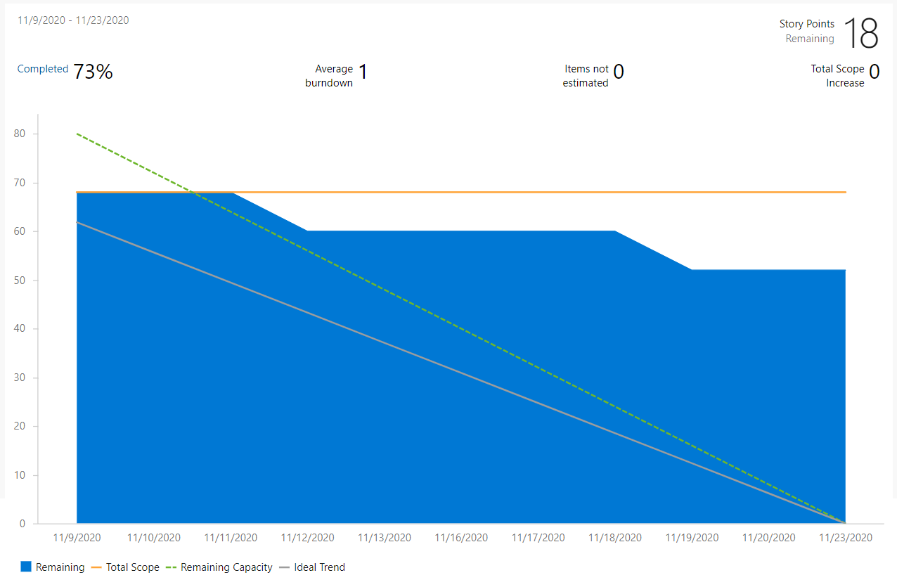

## Sprint 3:

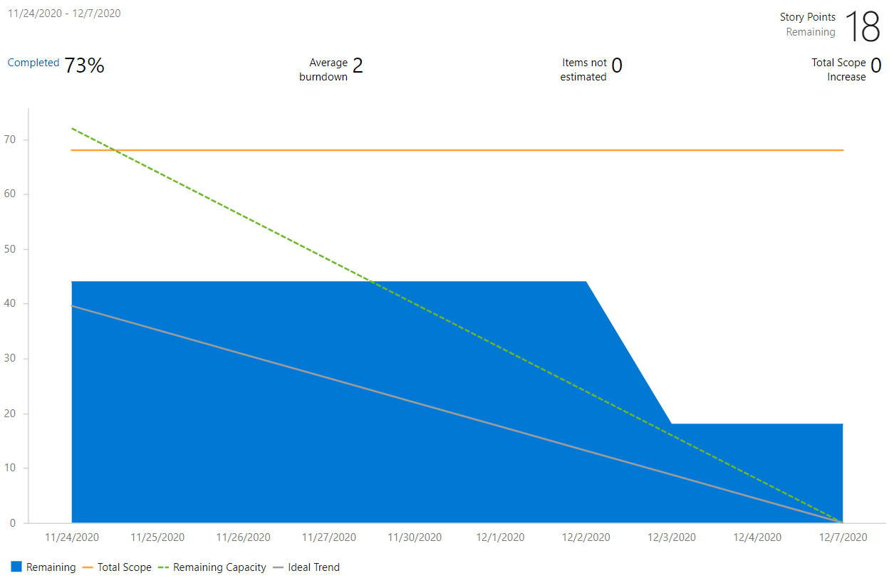

## Cumulative Burn Up:

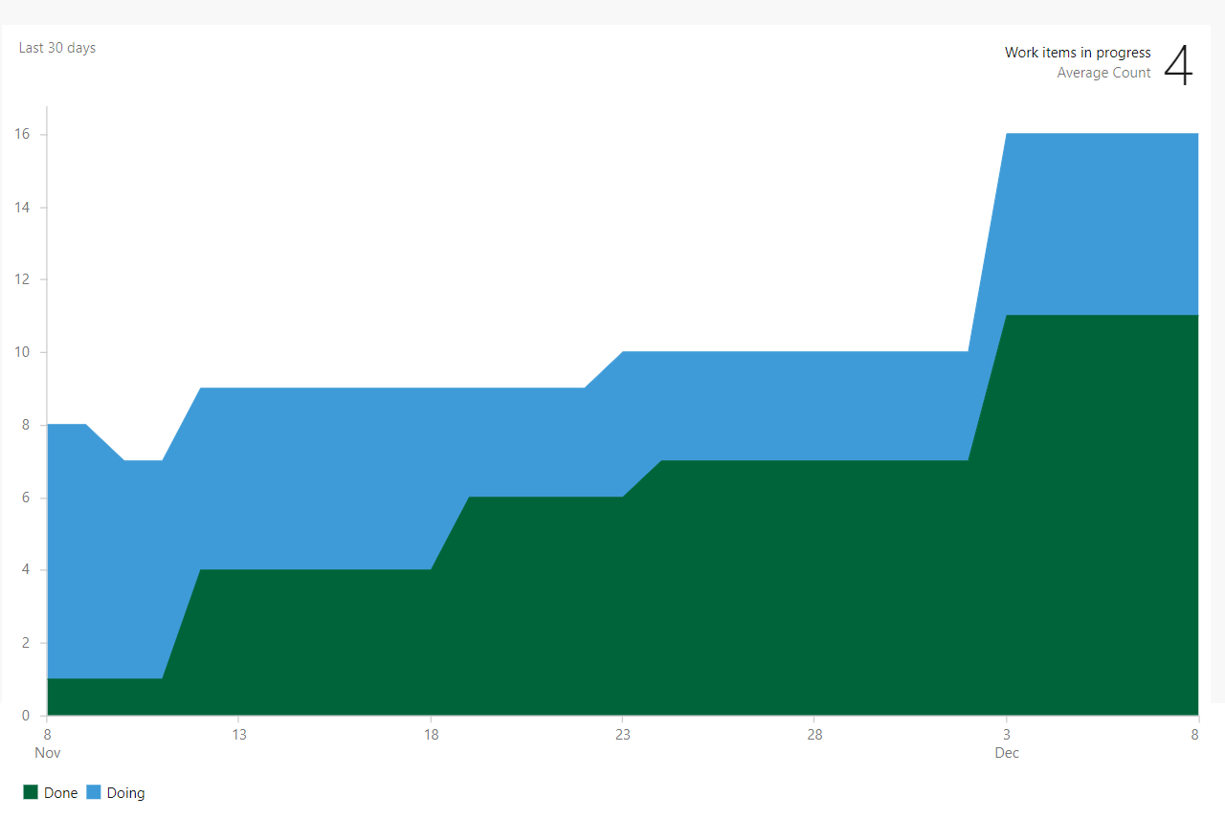

# Database Diagram

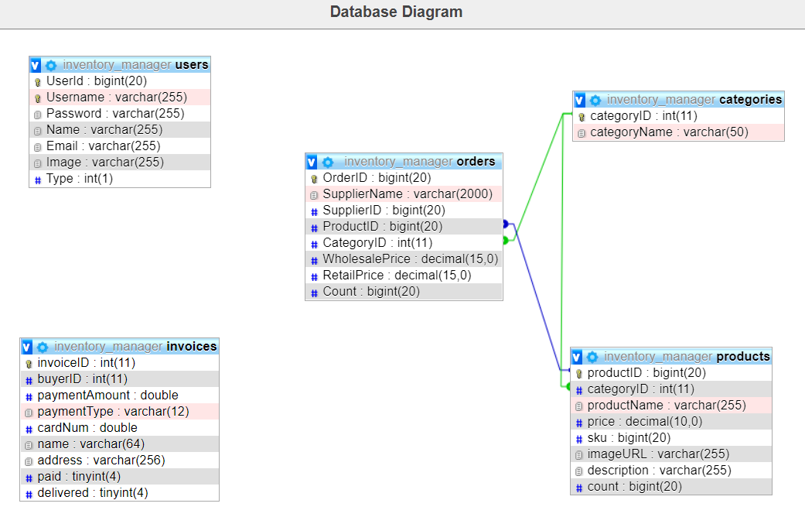

# Class Diagram